Practical: 2 | Implementation and Time analysis of linear and binary search algorithm
05/08/2026

Aim: To Implement Linear search and binary search and Time analysis their algorithms.

Algorithm:

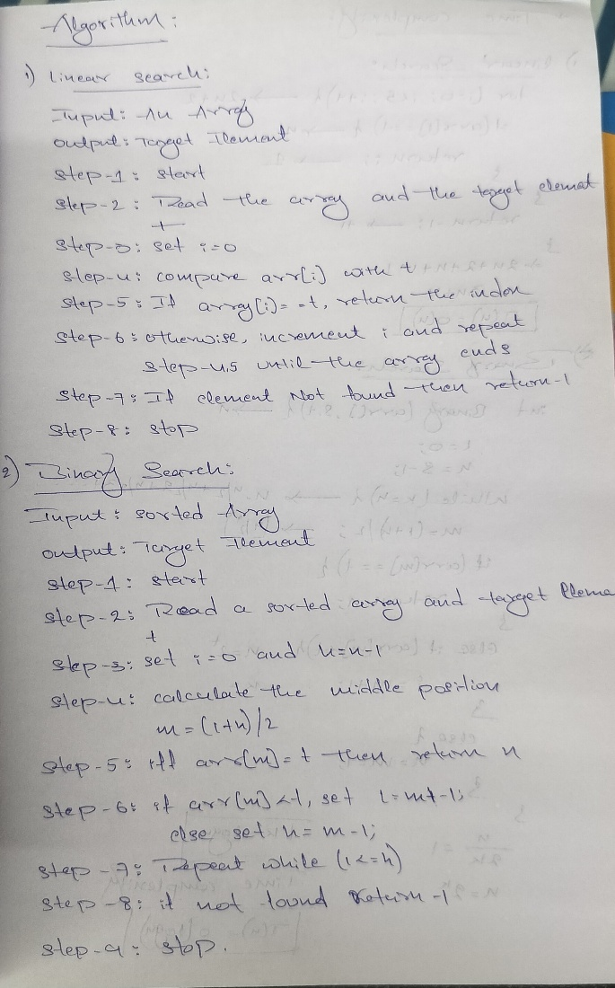
Program:

#include <iostream>
using namespace std;

Linear Search:
#include <iostream>
using namespace std;
int linearSearch(int arr[], int n, int key) {
for (int i = 0; i < n; i++) {
if (arr[i] == key) {
return i;
}
}
return -1;
}
int main() {
int arr[] = {10, 20, 30, 40, 50};
int n = sizeof(arr) / sizeof(arr[0]);
int key = 30;
int result = linearSearch(arr, n, key);
if (result != -1)
cout << "Element found at index " << result;
else
cout << "Element not found";
return 0;
}

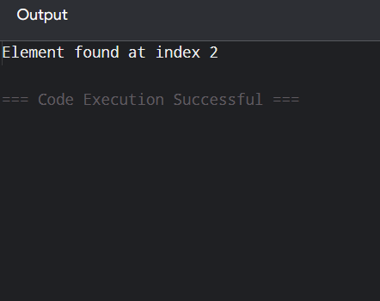
Binary Search:
int binary(int array[], int s, int t) {
int l = 0;
int h = s - 1;

while (l <= h) {
int m = (l + h) / 2;

if (array[m] == t) {
return m;
}
else if (array[m] < t) {
l = m + 1;
}
else {
h = m - 1;
}
}

return -1;
}

void display(int array[], int n) {
cout << "Array is:\n";

for (int i = 0; i < n; i++) {
cout << array[i] << " ";
}

cout << endl;
}

int main() {

int array[] = {2, 6, 7, 9, 11};
int n = sizeof(array) / sizeof(array[0]);

int t = 6;

display(array, n);

int f = linear(array, n, t);
int g = binary(array, n, t);

cout << "\nTarget element: " << t << endl;

if (f != -1) {
cout << "Linear Search: Element found at index " << f << endl;
}
else {
cout << "Linear Search: Element not found" << endl;
}

if (g != -1) {
cout << "Binary Search: Element found at index " << g << endl;
}
else {
cout << "Binary Search: Element not found" << endl;
}

return 0;
}

Output:

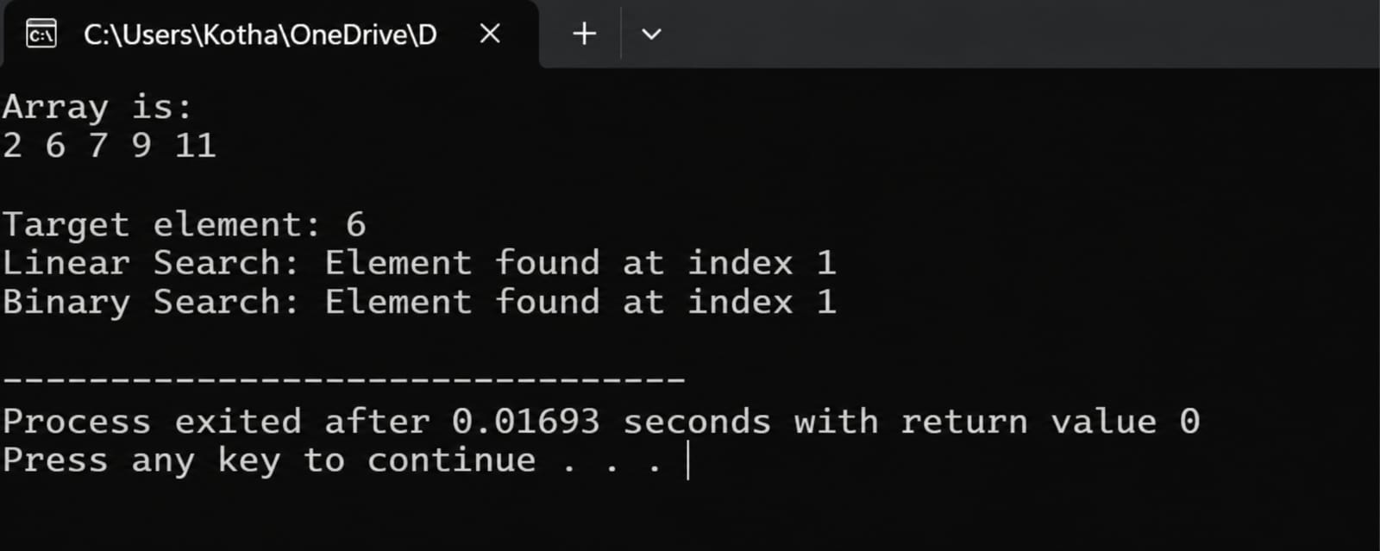
Time Complexity:

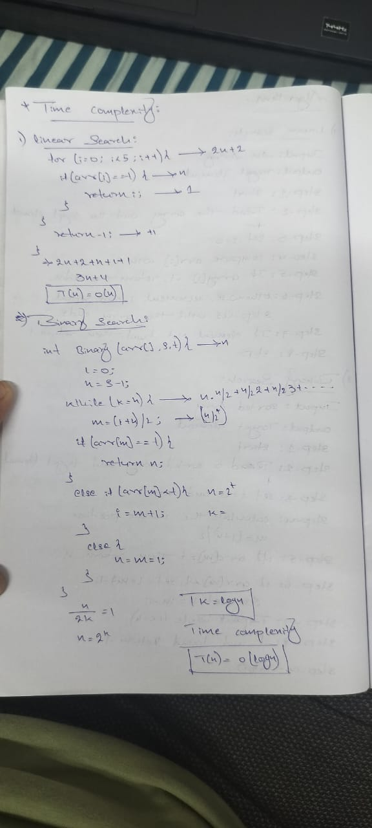

Conclusion:
Hence
From this practical of linear search, Binary search the algorithm and programs have executed successfully. And Time complexity has categorised into three ways as Best, average and worst.

